Sentinel 65X Assembly Notes

Power Supply
The power supply section of the Sentinel 65X PCB works roughly as follows:
- Unregulated DC power of between 6-12 volts is fed into the power supply from the barrel connector J7; the polarity of this connection is of no importance – it may be centre positive or centre negative.
- Power from the barrel connector passes through the fuse F1, and from there into the bridge rectifier D6. This will correct for the polarity of the power supply, allowing the system to function with any DC supply of appropriate voltage and current limits (2A recommended minimum).
- Unregulated DC power is then fed to the 5V regulator U6; this then provides the 5V power rail to the system. This rail is primarily used to generate 3.3V power, but is also available on the cartridge and expansion connectors.
- The 5V rail then powers the 3.3V regulator U8; this provides the 3.3V power used by most devices on the board.
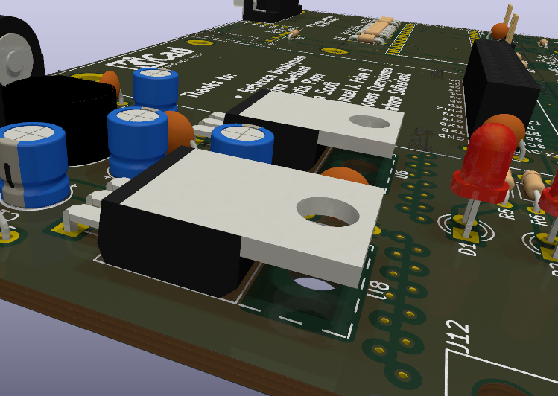
The two voltage regulators, U6 and U8, are to be installed as shown in the attached rendering: They are to be installed with the leads bent at a 90° angle, with the flat side facing up. The hole in each regulator is to be aligned with the matching hole in the Sentinel 65X PCB. This will allow you to feed an M3 screw from the bottom of the PCB, through the regulator tab hole, and through the mouting hole in a TO-220 heatsink.

The heatsink is then to be secured using an M3 nut. The use of thermal paste between the exposed metal of the regulators and the metal of the heatsink is recommended. Care must be taken when installing the regulators and heatsinks, to avoid blocking access to capacitors C15 and C17.

